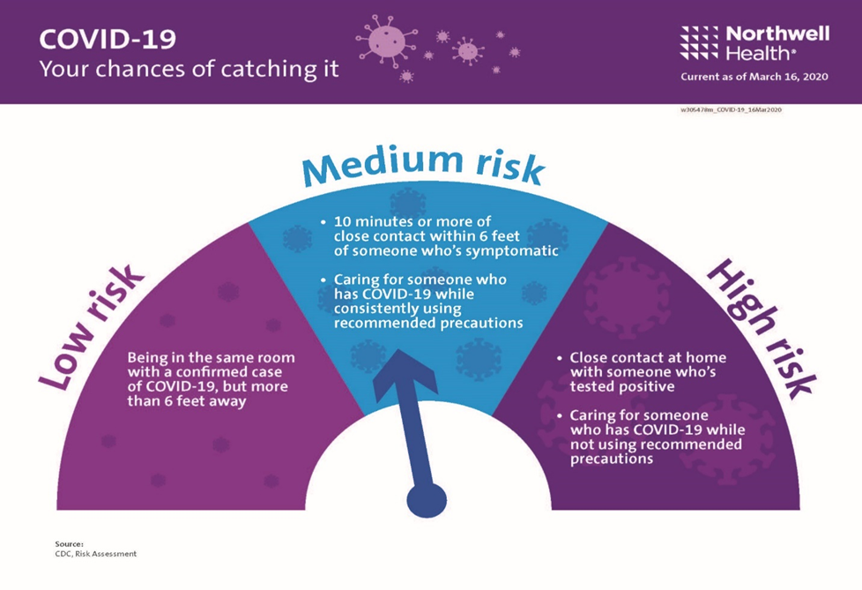

You can help stop COVID-19 by knowing the signs and symptoms:
Fever
Cough
Shortness of breath
Seek medical advice if you
Develop symptoms
AND
Have been in close contact with a person known to have COVID-19 or live in or have recently traveled from an area with ongoing spread of COVID-19. Call ahead before you go to a doctor’s office or emergency room. Tell them about your recent travel and your symptoms.

