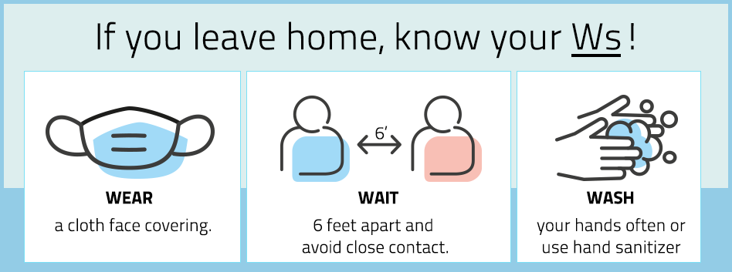
Empathy and Understanding during the COVID pandemic
It has been 3 months since the first case of COVID-19 appeared in Vermont. We have learned a lot in the past three months about the virus, how it spreads, and prevention. We know that wearing masks is a key part of reducing the spread of the virus from person to person. Despite this, some people still aren’t wearing masks, why?
For some, it can be physically difficult to wear a mask, for others, emotionally difficult. Wearing a mask restricts breathing and can be even worse for people that already have a medical condition that affects their breathing. Difficulty breathing can be scary and could cause anxiety. Also, masks trap in heat and the face is very sensitive to increases in temperature. Warm breath in a mask can make some people feel overheated. Some people associate medical masks with bad or sad memories such as, when a loved one was sick, or in the hospital. Others may find it challenging to not be able to see people’s facial expressions.
Even with all of these challenges, the good news is that most people can learn to tolerate wearing a mask. Some tips to help with this are:
• Think positive – “I’m going to make this work.”
• Practice! Start at home for just 1 to 5 minutes at a time and gradually wear the mask for longer times. Wear the mask while watching TV or making dinner. Start with short walks inside the house and then outside.
• Try different types or styles of masks
• Repeat a mantra “this too shall pass”
• Brush your teeth before wearing, chew gum, or suck on hard candy
• Try adding essential oils, such as lavender, to your mask for calming
If you are still unable to wear a mask, here are some tips to consider:
• Talk to your doctor or a therapist
• Call ahead to stores or other businesses to ask about their policy before you visit
• Be patient with yourself. Do the best you can.
Wearing masks can help keep everyone safe by reducing the spread of the virus. We strongly encourage you to wear masks when you are out in public or around others. If you see someone not wearing a mask be patient, ask them to wear a mask if you are comfortable doing so, and if need be, limit in-person contact with them for the time being. Together, and with a bit of kindness, we can get through this.

